MACH4METAL

Metalworking machinery
Transito 21,
6909 DA BABBERICH, Netherlands
Tel. + 31 (0)316 – 247123
Fax. + 31 (0)316 - 247956
info@mach4metal.com
www.mach4metal.com

Account No: 66.52.13.883
IBAN : NL33 INGB 0665 2138 83
BIC : INGBNL2A

TOS Vertical borer SKJ 8 F
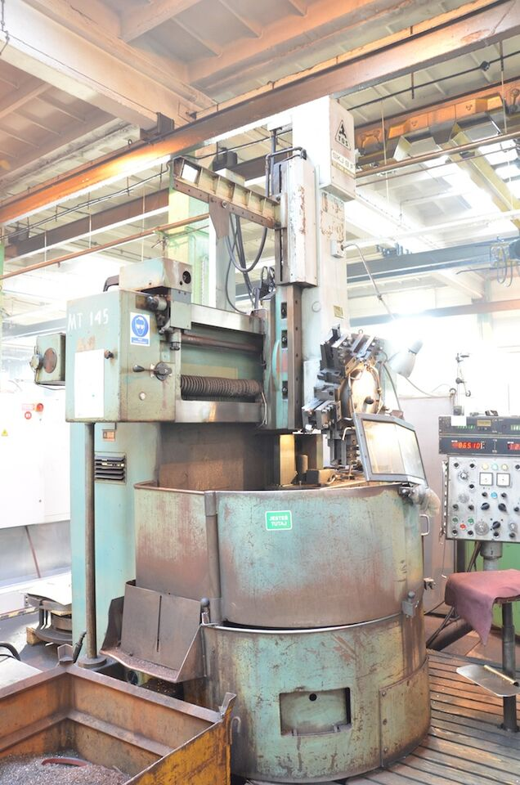
- Make : TOS CZ
- Type : SKJ 8 F
- Mach.No. :
- Age : 1984

- Table size Ø : 800
- Swing max Ø : 1.050
- Swing max Ø side head : 800
- Table load : 1.200

- Max. work pieces height : 630
- Vertical travel ram : 750
- Travel side
- Vertical travel cross rail :

- Max. table load : 2.500 Kg
- Cutting force carriage : 4.500 Kg

- Speed chuck : 6 – 304 Rpm
- Feeds : 0.08 – 4.5
- Rapid feed : 1.800 Rpm
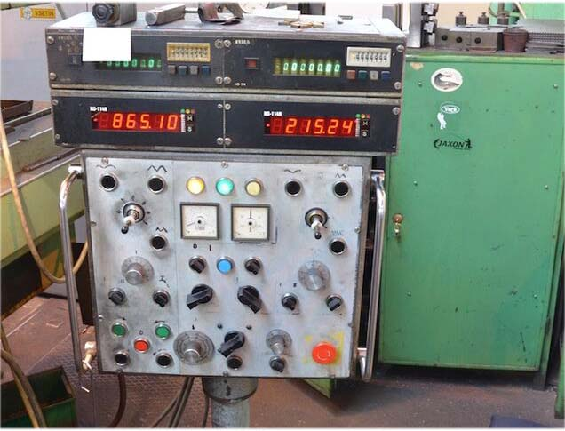

- 5 position revolver / bore Ø
- Size tool / Mtr.

Dimensions
- Length : 2.650
- Width : 2.350
- Height : 3.000
- Weight : 9.500
- Power : 40 kW

Please Note: The above information has been obtained to the best of our ability and belief from, and from the manufacturers where possible. It is given in good faith, but its accuracy can not be guaranteed. Accordingly, it will not form a representation or constitute contractual terms. We advise you to check any vital detail

